“The Question of ‘God’”
Skagit Unitarian Universalist Fellowship
April 18, 2021
Speaker: Rev. Bruce Bode
Celebrant: Jim Heard
Technical Genius: George Rogers-Clark

Chalice Lighting

Blessed is the fire that burns deep in the soul.
It is the flame of the human spirit touched into being by the mystery of life. It is the fire of reason, the fire of compassion, the fire of community, the fire of justice, the fire of faith.
It is the fire of love burning deep in the human heart, the divine glow in every life.
(Rev. Eric Heller-_{Wagner)}

Opening Words

Greetings to you once again from my home study in Port Townsend on another absolutely gorgeous, clear blue-sky, snow-capped mountain, spring day in the Pacific Northwest.

My sermon this morning titled “The Question of ‘God’” will, in large part, have to do with our use of language in addressing the ultimate mystery of being and the unanswerable questions of: “Why is there something rather nothing?” “Why is there being rather than non-being?”

The 13th century Sufi poet Rumi, born in Afghanistan in 1207, spoke to the limitation of language in addressing these questions in the following poem, which will serve as my Opening Words:

Out beyond ideas of wrong-doing and right-doing, there is a field. I'll meet you there.

When the soul lies down in that grass the world is too full to talk about.
Ideas, language, even the phrase “each other” don’t make any sense.

(Mevlana Jelaluddin Rumi, The Essential Rumi, tr., Coleman Barks)

Opening Song – “We All Come from the Goddess”

The title of a well-known painting by the French artist Paul Gaugin consists of three quintessential human questions: “Where do we come from? What are we? Where are we going?” (These are also the questions of a song in our teal-colored hymnal Singing the Journey, #1003: “Where Do We Come From?”)

Our Opening Song, a chant titled “We All Come from the Goddess,” addresses these questions from the feminine side of the male/female polarity. The YouTube video you are about to see and hear is sung by Mike Menefee, choir director of the Kitsap Unitarian Universalist Fellowship in Bremerton, and by his daughter Alena Hemingway. Mike Menefee also put together the accompanying images in this video.
(https://www.youtube.com/watch?v=LkTx57tjENU) [2:36]

Reading

Our reading for today’s service consists of statements of Joseph Campbell that I’ve pulled together from his interviews with journalist Bill Moyers transcribed in the book The Power of Myth. These statements relate to the necessary limitation of language in addressing our ultimate questions. This reading is set up for two readers in which I and Jim will alternate reading the sentences.

1st Reader: Life is mysterious; it is utterly beyond our apprehension and conception.

2nd Reader: Our senses are enclosed in a field of time and space. All our experiences take place within space; they take place in the course of time.

1st Reader: So, too, our minds are enclosed in a frame of the categories of thought. Everything we know is within the terminology of the concepts of being and non-being, single and many, true and untrue.

2nd Reader: But the ultimate thing (which is no thing) that we are trying to get in touch with is not so enclosed. We enclose it as we try to think about it.

1st Reader: “Transcendent” properly means that which transcends all forms of sensibility and categories of thinking. The “transcendent” is unknowable and unknown; it is beyond all names.

2nd Reader: The ultimate word in the English language for that which is transcendent is
“God.”

1st Reader: God is a thought, God is an idea, God is a name; but its reference is to something that is transcendent to thinking and naming.

2nd Reader: God can be personified in many, many ways. Is there one god? Are there many gods? These are merely categories of thought.

1st Reader: But God, as the ultimate mystery of being, is beyond thinking.

2nd Reader: God is transcendent finally of anything like the name “God.”

(Joseph Campbell, statements from The Power of Myth with Bill Moyers)

Musical Meditation: Hymn #286, “A Core of Silence”

There’s a hymn in our gray hymnal with which I suspect most of you are not familiar titled “A Core of Silence.” It was composed by musician and lyricist Jim Reilly, born in 1943, the hymn being published in 1986.

And, like the reading you just heard from Joseph Campbell, this hymn also speaks to the necessary limitation of language in addressing the deepest questions of heart and mind … and how the word “God” may relate to this subject.

This past week I did some exploration on the Internet and found an email thread, begun in 2017, in which some Unitarian Universalists were offended by the third verse of this hymn. So, George, could I have the words of this hymn put on the screen, and I’ll show you the source of their irritation.

Verse 1 (Please note the quotation marks in this verse):

- A core of silence breathes beyond all words, or else the words have little worth; to “Heart” or “Soul” or “Spirit” it comes forth (the words we name them matter not).

Verse 2:

- And half the music lies within the pause between the arches of the heart; the print upon the page means less than ink unless the white and black both speak.

There’s no offense in these first two verses … but the third verse is the one that has set the teeth of some folks on edge:

Verse 3:

- The “True Religion” gathers up its text:
“In the beginning was the Word.” But I seek quietness behind that start and name it nothing, much less “God.”

One person in the email thread said,

“This is the most offensive thing in the hymnal. In my personal copy, I’ve got a big “X” in marker over this one. Nope. No way. Not ever. Nope.”
(August 8, 2017 at 2:50 pm)

I doubt that the person who wrote this email expected the composer Jim Reilly to respond, but he did about five weeks later, humorously quipping:

“To write the “most offensive thing” in a U-U hymnal is quite an achievement, even if I wasn’t trying, and even if I think the interpretation above is mistaken – i.e., the hymn is not concerned with atheism, or a belief or lack of belief in “God” – it [the hymn] has to do with my feeling that some kinds of “spiritual experience” […] are independent of language and the limitations it imposes – I do have a kind of disdain for language, necessary as it is, and as much as I have devoted part of my life to it – but then it was the language bias of so many U-U experiences that drove me to write the hymn – it’s not much of surprise that some U-U folk wouldn’t like it.”
(Jim Reilly, September 18, 2017 at 9:51 pm)

Then, about a year and a half later, Jim Reilly jumps on this email thread again, having found a sermon on his hymn by the Rev. Frances Dearman, a Canadian Unitarian Universalist minister and ministerial colleague. This time Jim Reilly wrote:
“I am much indebted to Frances Dearman for the “close reading” of my hymn …. Dearman understands what I tried to communicate and how the text and music
work together, including the lack of meter in the tune.” (February 9, 2019 at 12:25 pm)
So, I looked up Rev. Dearman’s sermon. Here’s a taste of it in which she summarizes the message of the hymn saying:

“This is poetry; the words are more tightly woven than their simplicity at first suggests. Let’s try a paraphrase first, to try and get at the literal meaning: Reilly tells us that he senses a noiseless centre to the universe, something that seems alive; this centre communicates in silence – words do not bear the meaning; we call to this centre with certain names, and it responds, but the names don’t really matter. The meaning it offers us depends as much on what is unsaid, as on what is said. Some proclaimed authority relies on word. But the poet looks behind the words to the quiet centre; the poet feels no need to name the holy.” (Link to sermon by the Rev. Frances Dearman: http://uuolinda.org/wp-content/uploads/2018/02/Core-of-Silence-11Feb2018.pdf )

And, here, finally, is a YouTube video of “A Core of Silence,” words and music by Jim Reilly, video by Julia Stubbs. (https://www.youtube.com/watch?v=9HCWNCWQYMQ) [1:21]

SERMON, PART 1: “The Question of ‘God’: The Use of the Word ‘God’”

Introduction

I’ve divided my sermon this morning into parts. Part one, which I’ve timed at about seven minutes, has to do with the use of the word “God” … and part two, which I’ve timed at about twenty minutes, will deal with different concepts of God.”

“God” as word and concept

So, “God” – G-o-d – is a word. And, like all words, it is a pointer and a symbol that reflects and tries to elucidate certain human experiences, emotions, and ideas.

Historically, the word “God” has been the primary word that we English-speaking people have used to refer to what is regarded as ultimate and most real.

In this sense, “God” is a “category word” for speaking of the reality that, for us, is highest, deepest, largest, and greatest.

Taking the word in this sense, whatever fills the category of highest/deepest/largest/greatest for you is “God.” Whatever is most essential and real for you, whatever most seriously grips you, whatever you ultimately serve, that is “God” for you.

In our everyday language you might hear it said of an individual, “Money is his God; money is her God” … meaning, “Money is what grips that person; money is what he/she serves.”

Typically, such a statement is not only a descriptive statement but also a prescriptive statement … that is, a judgment is implied … namely, “money” is not an appropriate thing to which to devote one’s self.

In theological parlance, revering money is an “idolatry”: putting a “false god” in the place of the “true God” … swapping the less real for the more real … or, as theologian Paul Tillich expresses it, substituting a “penultimate concern” for an “ultimate concern.”

Thus, the word “God” is not only a word expressing what is most essential and real for us, but it’s also an invitation to reflect on what it is that ought to be considered most essential and real. Historically, it’s a word that propels us toward the largest that the human mind can conceive and the deepest that the human heart can feel.

In considering the question of “God,” we are asking:

What is it that is ultimately real?
What is it that is self-existent?
What is it that abides through all the changes of life and being? What is it that always was, is, and will be?

And, we are also asking: What, if anything, does this ultimate reality ask of us?

The approach of Eckhart Tolle

Historically, as I say, the little English word “God” has been the primary word to usher us into the realm of these questions and concerns. But is that still the case in our time? Does the word “God” still promote personal understanding and public communication in regard to the ultimate questions of life and being? Is the word “God” still a useful word in comprehending reality and communicating that comprehension to others?

In his book The Power of Now, author Eckhart Tolle says that he typically uses the “Being” to speak of: “… the eternal, ever-present One Life beyond the myriad forms of life that are subject to birth and death.”

And, “Being,” he says, “is not only beyond but also deep within every form as its innermost invisible and indestructible essence. This means that it is accessible to you now as your own deepest self, your true nature.”

But the question is then put to Eckhart Tolle, “When you say Being, are you talking about God? If you are, then why don’t you say it?

Eckhart Tolle answers, as follows:

“The word God has become empty of meaning through thousands of years of misuse. I use it sometimes, but I do so sparingly.

“The word God has become a closed concept. The moment the word is uttered, a mental image is created, no longer, perhaps, of an old man with a white beard, but still a mental representation of someone or something outside you, and, yes, almost inevitably a male someone or something.

“Neither God nor Being nor any other word can define or explain the ineffable reality behind the word, so the only important question is whether the word is a help or a hindrance in enabling you to experience That toward which it points.

“The word Being explains nothing, but nor does [the word] God. Being, however, has the advantage [in] that it is an open concept. It does not reduce the infinite invisible to a finite entity. It is impossible to form a mental image of it. Nobody can claim exclusive possession of Being. It is your very essence, and it is immediately accessible to you as the feeling of your presence, the realization I am that is prior to I am this or I am that. So it is only a small step from the word Being to the experience of Being.”

Personal approach and suggestion

Like Eckhart Tolle, I have no problem using the word “God” for myself and with those who know how I am using the word. But, publicly, I share Tolle’s concern. And, though I do not wish to easily give up using the word “God” because of its rich and colorful history, I confess that in most current contexts, the word “God” will not escape my lips, as my meaning would be misunderstood.

Thus, let me venture the opinion that there isn’t anything magical or mandatory about the use of the word “God.”

And, let me offer the suggestion that if the word “God” has ceased to have meaning for you;
or if it has become corrupted for you to the point that you react negatively against it; or if you find that the word blocks you from deeper religious and philosophical
contemplation; then, for God’s sake – and by that I mean, for the sake of that which is highest and holiest and largest and deepest – discard the word “God” and find a word or words that do work for you. That is, find a word or words that usher you into the largest, the deepest, the greatest reality that you can conceive and even beyond what you can conceive.

Musical Interlude

I want to move to Part 2 of this sermon, which will have to do with briefly exploring some of more common concepts of “God.” But let’s take a musical break, and I’ll introduce this second part of the sermon with a hymn from our gray hymnal titled “Mother Spirit, Father Spirit.”

This is a hymn that was composed by the Rev. Norbert Capek, who lived from 18701942, and at one time headed the largest Unitarian congregation in the world, a congregation of 5000 members in the beautiful city of Prague in the Czech Republic.

That congregation was decimated by both World War II and the Communist takeover of Czechoslovakia following World War II, and Rev. Capek himself was arrested, imprisoned, and executed in a concentration camp in Dachau, Germany in 1942. But, prior to that, on June 4, 1923, he created a Flower Communion service, which later found its way to Unitarian Universalist congregations here in the United States.

Now, let’s listen to another continuing contribution of Rev. Capek, a lovely hymn in which he addresses the ultimate questions of our being through both sides of the male/female polarities of our language. “Mother Spirit, Father Spirit,” sung by Jan Jaffe. (https://www.youtube.com/watch?v=G8NaPiFYZoA) [1:44]

SERMON, PART 2: “The Question of ‘God’: Concepts of ‘God’”

A “majority” concept of “God”

As I’ve indicated, there’s not just one concept of “God,” there’s several.

However, you could say, and rightly so, that there is a majority concept of “God” – certainly in our country and culture. And when pollsters and knock-on-the-door evangelists ask, “Do you believe in God?” it’s some kind of theistic concept of “God” they are assuming.

They are assuming a concept in which “God” is understood as a single, directing consciousness set apart from “natural reality,” or “creation” in their case, but capable of intervening in it; and, usually, an everywhere present, all-knowing, all-powerful creator and sustainer of life and being.

This is a typical “theistic” concept of “God.” But the important thing here is that it’s not the only concept; it is one among several.

Thus, in using the word “God,” it’s helpful to indicate which concept of the word is being used – whether, for example: theistic, deistic, polytheistic, pantheistic, or panentheistic.

Theism

So, let me summarize these concepts of “God” … beginning with “theism,” which, as I just said, is typically understood as the idea of a presence and a power that stands apart from natural or material reality and is the conscious Creator of that natural or material reality … a Power, an Intelligence, an Infinite Being that creates and cares for and can intervene in the natural/material world; a personal presence or a personal being with whom one can relate and upon whom one can call; a being and a reality that can be both loved and feared.

I thought it might be helpful to provide diagrams of these different concepts of God. (And, please overlook, if possible, the primitiveness of my artistic efforts.) The theistic concept of God could be diagrammed as follows:
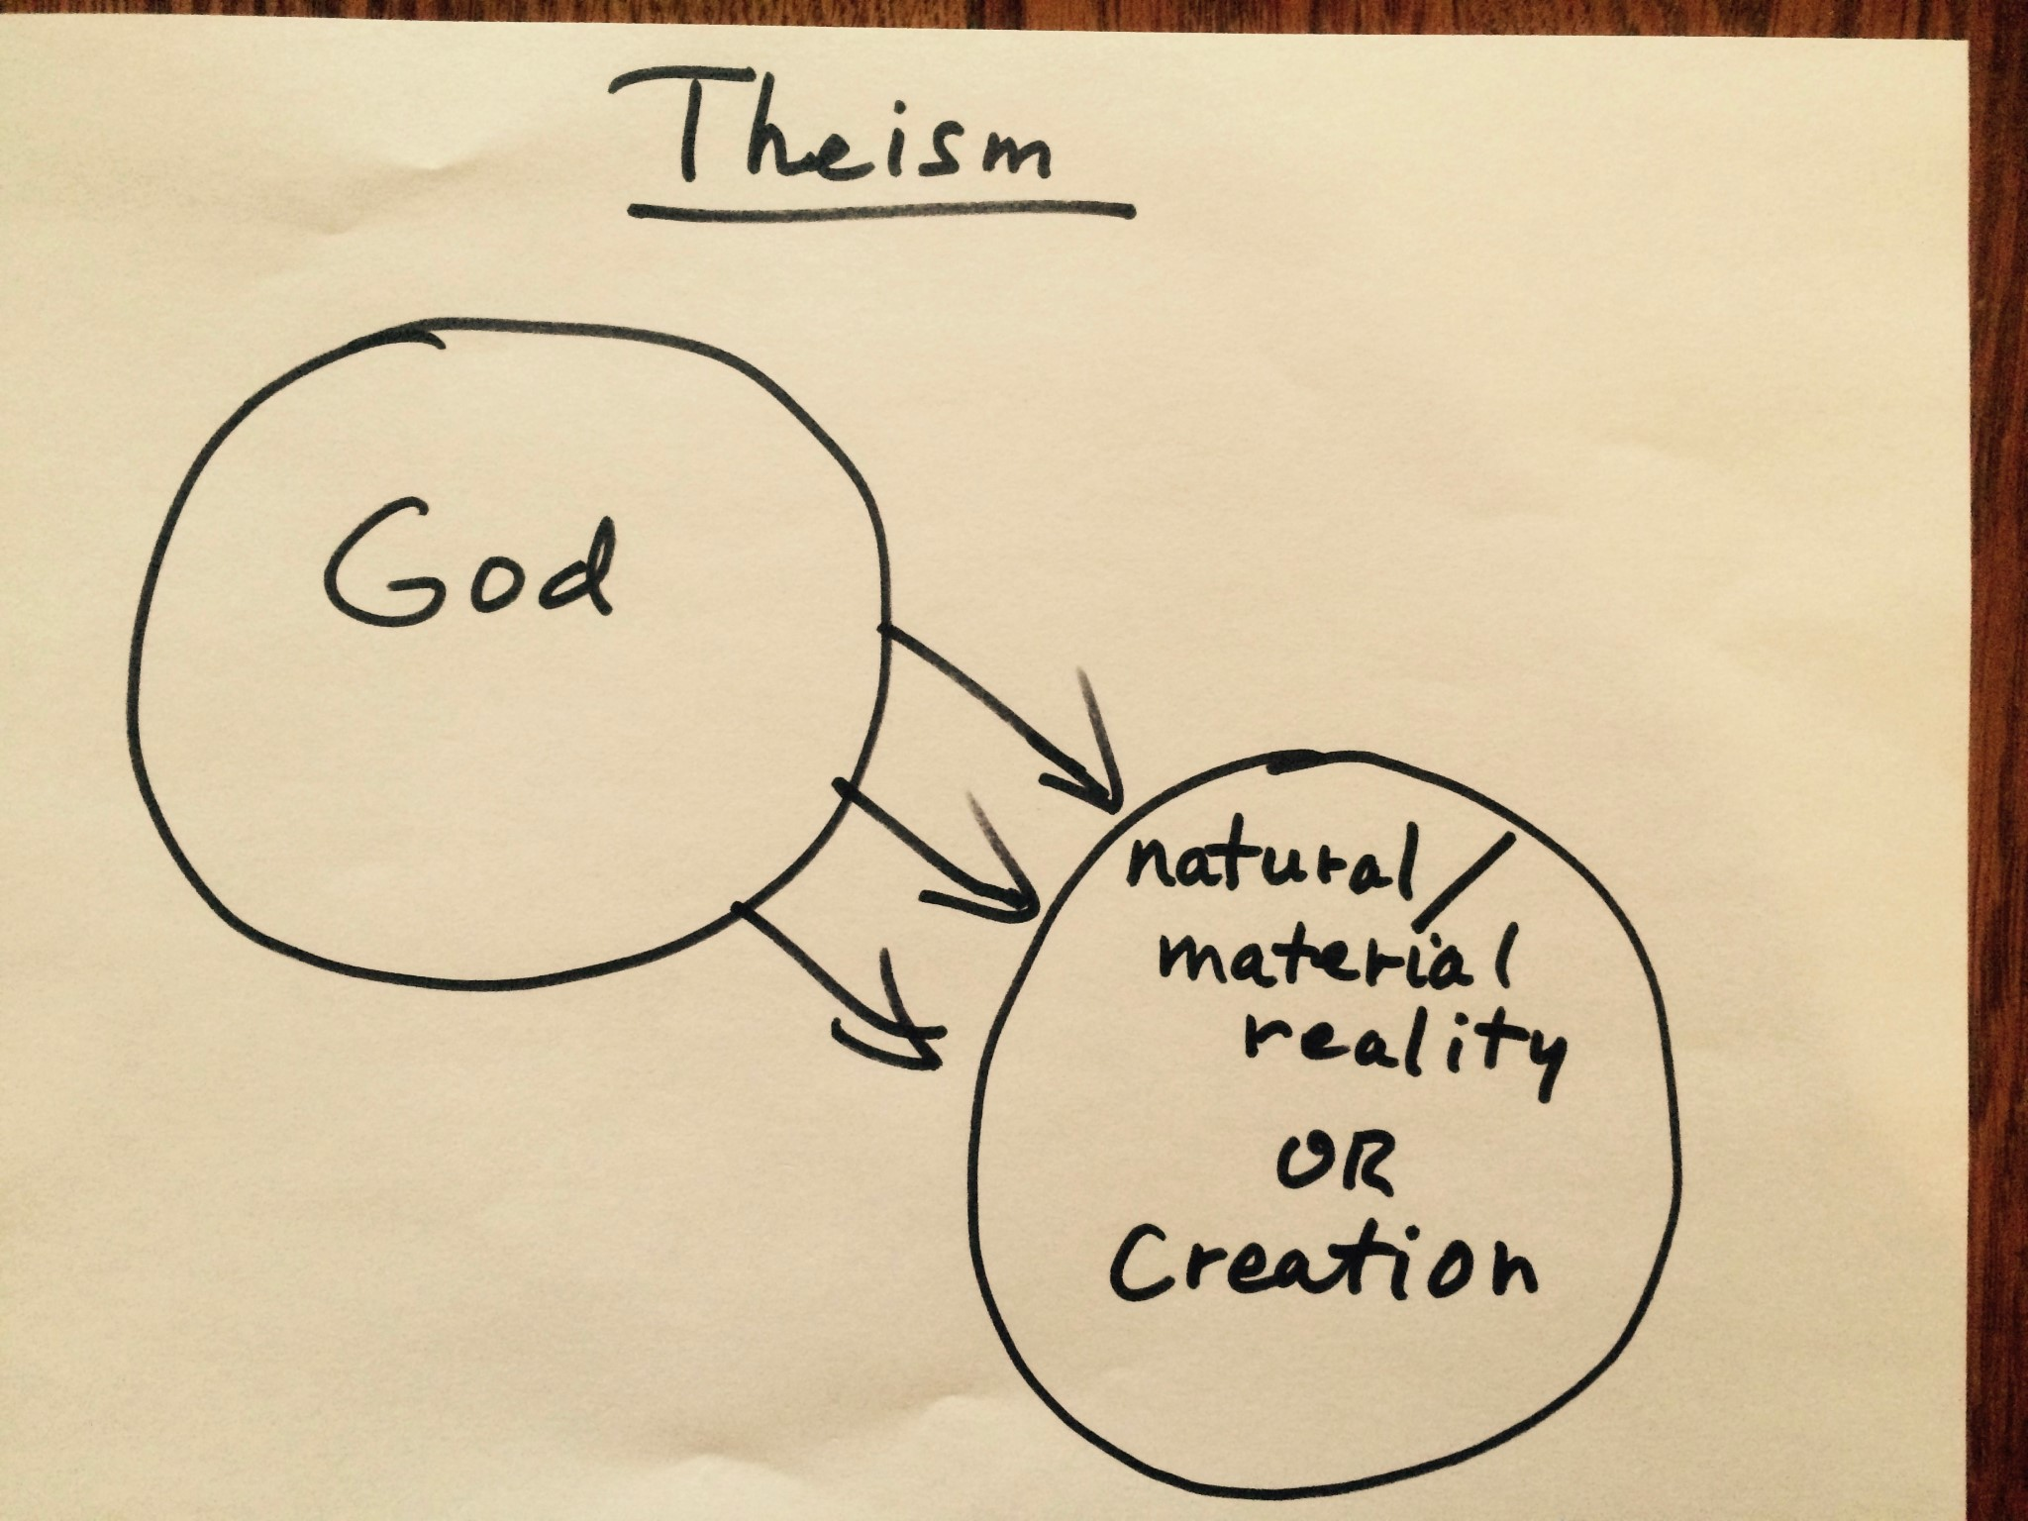
Two separate circles with arrows pointing from God to the material reality. The separate circles indicate a concept in which God is understood as a separate reality or entity from natural/material reality or creation. And the arrows coming from God to natural/material reality or creation indicate God’s creation and the continued maintenance of all that has been created.

Atheism

This theistic concept of God, as I say, is the majority concept of God in our part of the world. Many assume it is the only concept of God, including most atheists. So, a denial of this theistic concept of God is how one might define “atheism.” The “a” in “atheism” means “not;” thus, “not” theism = “a-theism.”

One might diagram atheism by simply writing a large “X” through the diagram of theism, thus, crossing it out and indicating a denial of that concept.

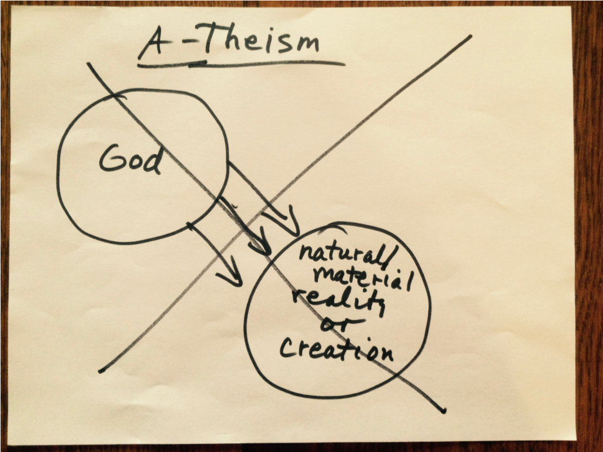

Technically, one could be an atheist but still hold to another concept of God. But most persons who call themselves atheists want to distance themselves from the theistic concept of God and may not even be aware that other concepts of God exist … or be open to them … though, in other cases, atheism might express a disinterest in or disagreement with any concept of “God” or to any subjects related to the question of “God.”

Apatheism

For example, the spouse of a member of the congregation I served in Port Townsend described himself, not as an atheist, but as an “apatheist.” He drolly proclaimed that “He just didn’t give a rip,” “apatheist” being derived from the word “apathy” – “a-patheist.” (I’m not certain how to diagram the apatheist position.)

On the other hand, Unitarian Universalist theologian Forrest Church says:

“When people boast to me that they don’t believe in God, I ask them […] to tell me a little about the God they don’t believe in. Almost surely, I don’t believe in
‘him’ either.” (Bringing God Home: A Traveler’s Guide, p. 20)

Deism

A second concept of God is that of “deism.”

“Deism,” like theism, is the concept of a Creator God who has set the natural/material world or creation in motion so that it operates according to its own principles and laws. But the deistic Creator, then, stands apart from the natural/material world or creation, much like a clock-maker who has wound up a clock and set it running and does not interfere or intervene with its movement.

Our human task in this deistic concept of God is to investigate and rationally understand nature’s laws … to create a better world with the tools we have been given and within the created conditions in which we find ourselves.

This concept of God can, again, be represented with two circles, but this time with a firm line separating the circles … and no arrows from God to natural/material reality or creation, thus indicating a separation of the Creator from the created reality.

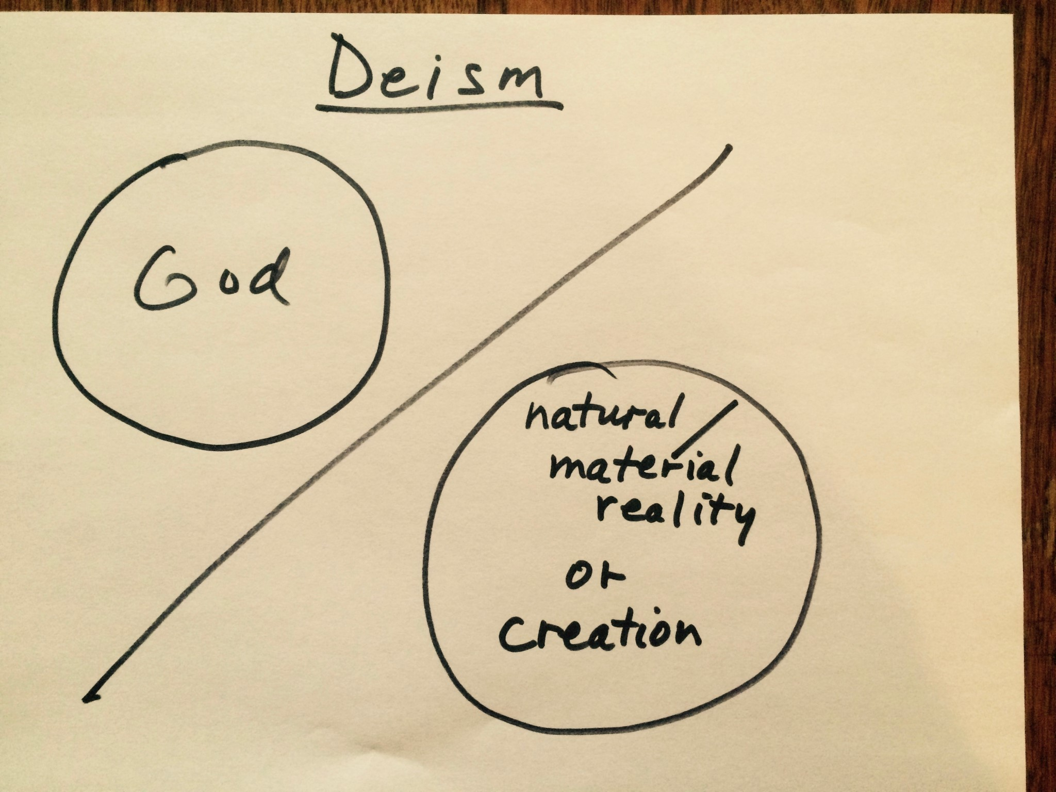

The deistic God is the God of several of America’s founding fathers: Washington, Jefferson, Ben Franklin, Ethan Allan, and others.

This is also for many in our secular culture the concept of God in practice – that is, a sense of some originating Creator God, but One that is quite distant and doesn’t need to be reckoned with or consulted on a daily basis … perhaps, an occasional nod of the head or tip of the hat to the “Man in the Sky,” while life goes on with all its hustle and bustle … almost the sense of: “I won’t bother you, if you don’t bother me.”

Polytheism

A third concept of God is polytheism, a concept of God still very much alive in many parts of the world, and a concept being picked up again in our part of the world in neopagan and New Age religion.

In this concept, instead of a single, unified creative presence and power, there is a sense of a plurality and multiplicity of powers, of gods and goddesses.

Some polytheists regard their gods and goddesses as being aspects, facets, or emanations of a greater Godhead, or, yet again, as manifestations of a common, impersonal entity.

Still others give a psychological interpretation to the gods and goddesses, understanding them as archetypes of the human psyche and of nature.

Polytheists do not usually worship all the gods and goddesses equally but are devoted to particular gods or goddesses, which may change as one’s life circumstances change.

In Hindu temples, for example, you will find a number of images of gods and goddesses in separate rooms and buildings representing different powers, but all in the same temple.

To my mind, the various male and female saints in Catholic cathedrals function in much the same way as the gods and goddesses of Hinduism.

Polytheism may be diagrammed in a similar way to theism, except with a plurality of divine realities and arrows coming from them.

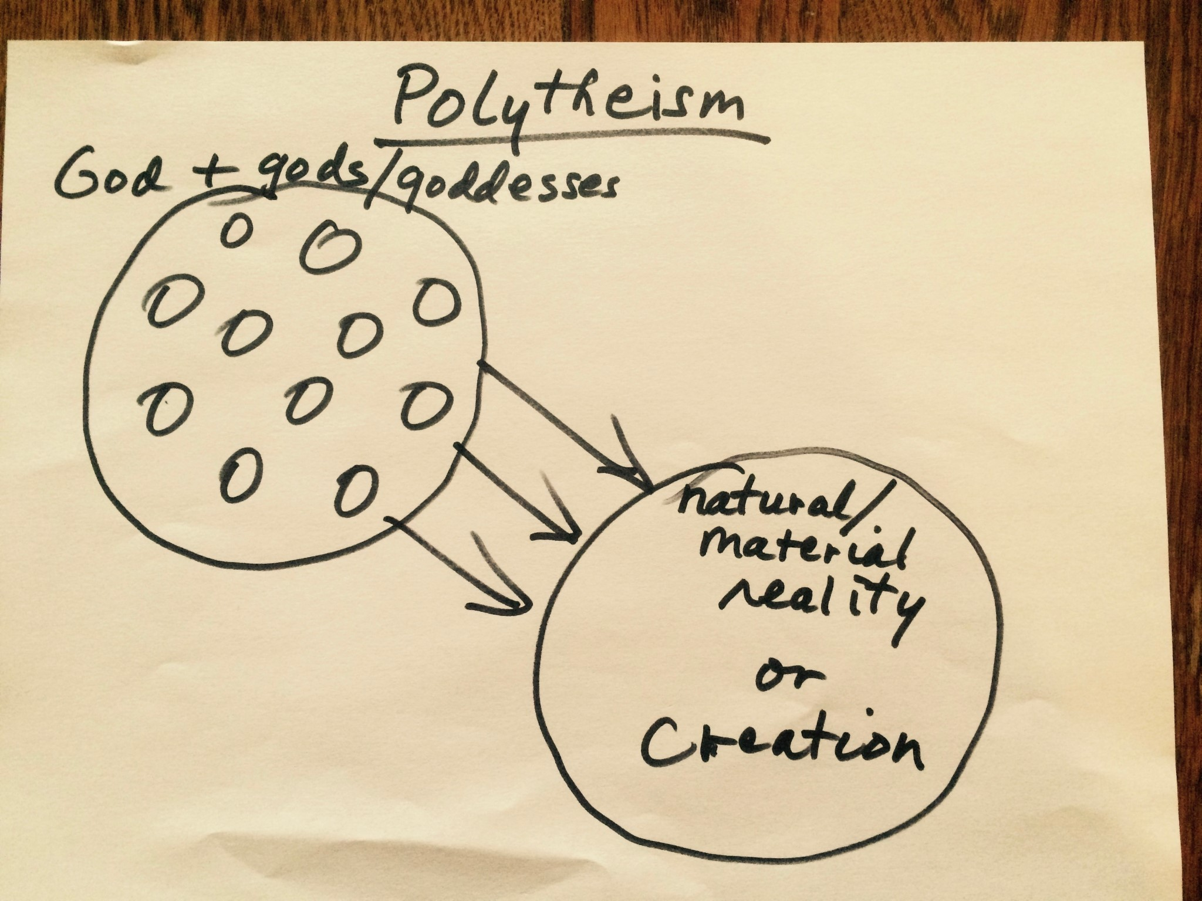

(NOTE: Sometimes, I see the word “Goddess” used in place of the word “God.” I understand the reason for this, as “God” in our part of the world is usually thought of and imaged as male … and, thus, the desire to correct this mis-understanding. To my mind, however, the attempted correction is an over-correction, as it substitutes female for male imagery. “God,” as a word pointing to ultimate reality, contains both the male and female … or is beyond/transcends the categories of male or female. In terms of capitalization, I typically write “God” with the upper case “G,” but the gods and goddesses with the lower case “g,” indicating that “God” contains/transcends the gods and goddesses.)

Pantheism

A fourth concept of God is that of “pantheism.” “Pan” means “all” and “theism” means
“God” … and so “pan-theism” means “all is God” or “God is all.”

It can be diagrammed as a single circle but, actually, it’s two circles; it’s just that one is on top of the other, indicating that God and Natural Reality are one. They coincide; they’re identical.

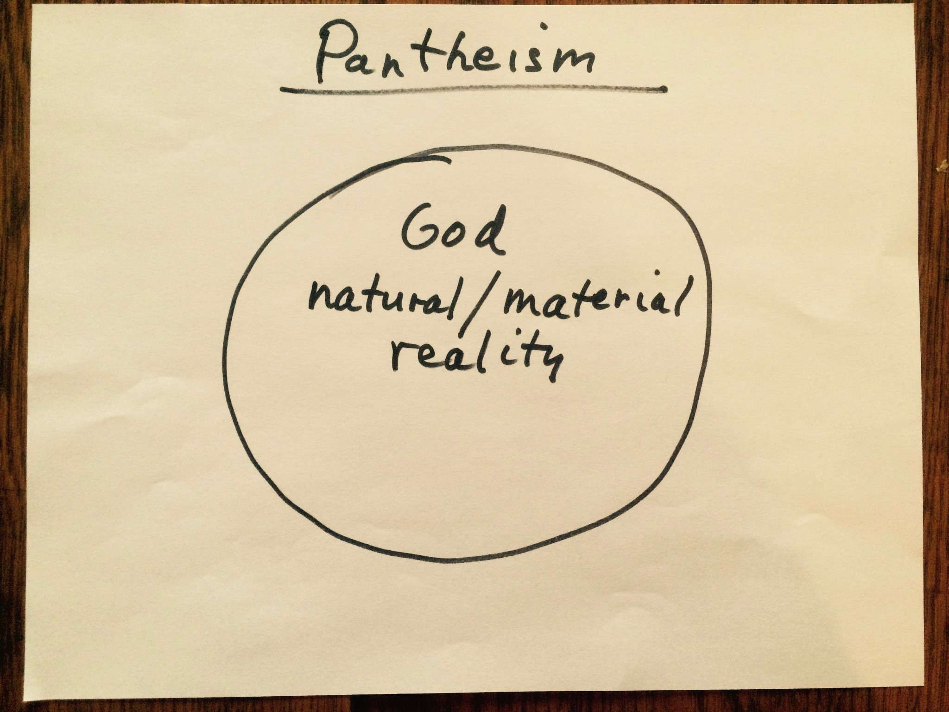

In pantheism, no new facts or information are added to reality; there’s no separate realm of God. Rather, natural reality is also spiritual reality – and visa versa. It’s one coin that can be looked at from two different sides. As poet Charles Baudelaire puts it:

“The natural world is a spiritual house.... We walk through forests of physical things that are also spiritual things, that gaze upon us with affectionate looks.”

In pantheism, it’s not that the facts and processes of the natural world are any different because of an understanding of God. However, one’s way of relating to the natural world might be different because of an understanding of God. Either nothing is a miracle or everything is a miracle; either nothing is divine or everything is divine. In pantheism, everything is a miracle and everything is divine!

Pan-en-theism

The fifth and final concept of God I’ll describe is one that is gaining in usage and popularity, namely, “panentheism.”

“Panentheism” is “pantheism” with an important little connector syllable in the middle, the syllable “en,” which means “in.” The force of this little syllable “en” indicates a connection that goes both ways.

Thus, again, “pan” means “all,” and “theism” means “God,” and so you get “pan-entheism – I like to hyphenate it for clarification – which means “all in God.”

And, to give it the full meaning, you need to go the other way as well; that is, “God in all.”

“All in God and God in all”… that’s the idea of “pan-en-theism.” As the thirteenth century, medieval mystic Mechthild of Magdeburg said:

“The day of my awakening was the day
I saw all things in God and God in all things.”

To diagram “pan-en-theism,” simply take the single large circle of pantheism and draw an even larger circle around it, thus enclosing it. Then, also put a dot or point in the center. This indicates a concept in which God is understood as both the circumference and center of all natural or material reality, both greater than all natural/material reality and at the same time present in each part of natural/material reality.

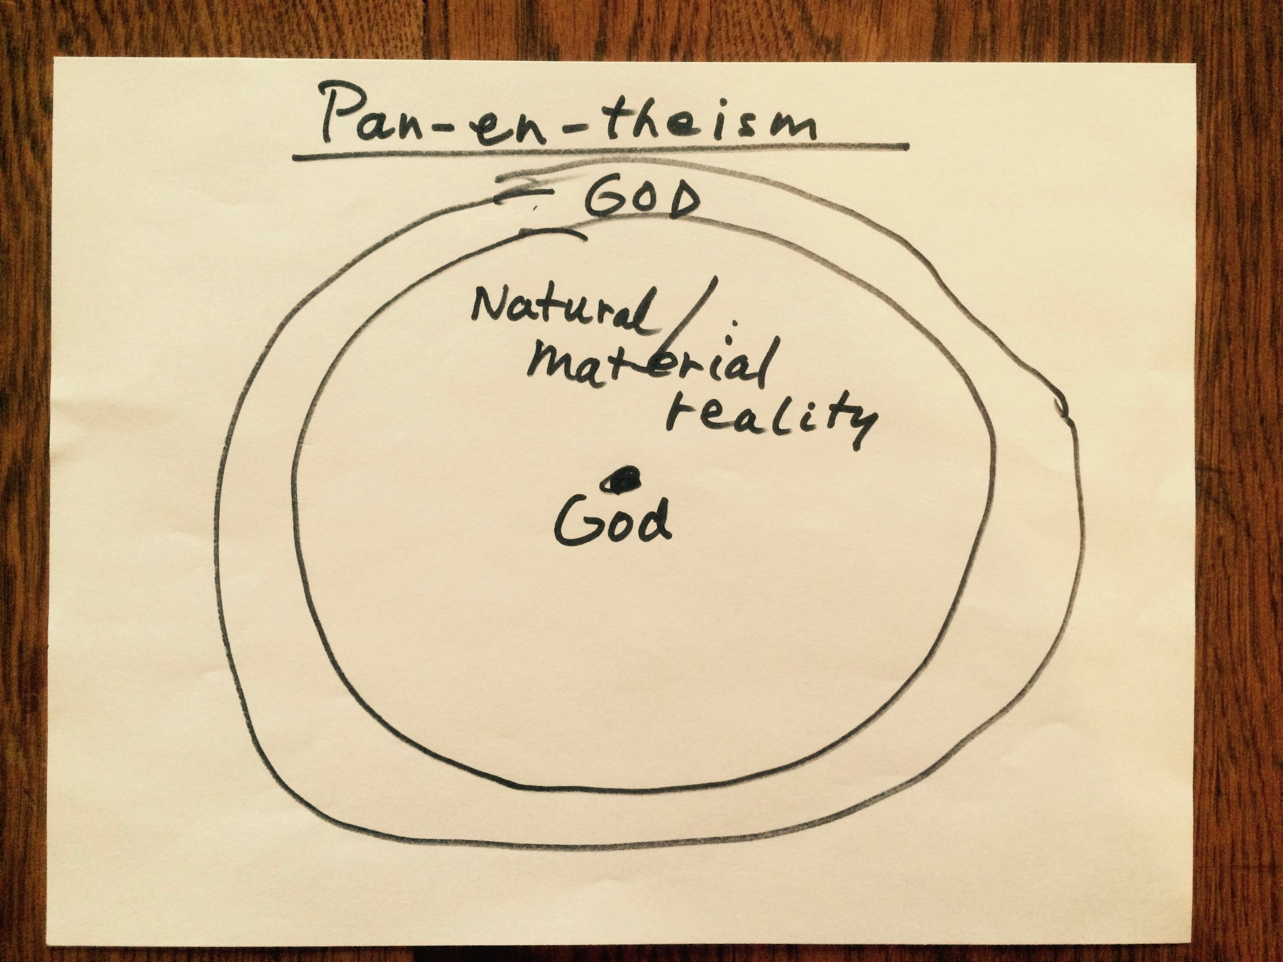

Thus, if all things fell out of existence, if the universe and all there is in it were to disappear into some black hole or another, “God” would still “be” as the power and potential of new universes and new beings.

In this concept, God is not exhausted by natural/material reality nor coincident with it as in “pantheism.” This is the “transcendence” of God, indicated by the outer circle of the diagram – “All is in God.”

But, in this concept, God is also at the center of each existing thing, the power of being in each and all, from minnow to mountain, from quark to quasar. This is what is called the “imminence” of God, indicated by the point at the center of the diagram – “God is in all.”

What “pan-en-theism” does is to bring together aspects of both theism and pantheism – the transcendence of theism along with the imminence of pantheism.

In a pan-en-theistic concept, as well as in a pantheistic concept, God is not a being; but, rather, to borrow a term from theologian Paul Tillich, God is “Being-itself,” or, as Eckhart Tolle puts it, simply “Being.” (Tillich also uses language of “God” with metaphorical elements – “God” as the “power of Being” or the “ground of Being.”)

In Tillich’s understanding, to ask “Does God exist?” is a wrongly put question. “God” does not “exist.” That is, “God” is not one existing being among others, not even the greatest of existing beings; rather, “God” is the ground of all that exists, like the ground out of which vegetation emerges and back into which it falls.

“God,” in these concepts, is the word that we use to point to the power and possibility of anything at all to be.

Again, in Tillich’s approach, the question “Do you believe in God” makes no sense, for “God” is a word that points to the power that makes belief of any kind possible. It’s a word that points to the very ground out of which one could even ask such a question.

A necessary frustration in speaking of “God”

I have briefly summarized the main concepts of “God.” And, here, I will venture the opinion and suggestion, as I did earlier with respect to whether or not to use the word “God,” to say that these concepts point beyond themselves to what cannot be conceptualized. Just as the word “God” is a word and symbol that points beyond itself to that which cannot be captured in words, so the various concepts of God point beyond the concepts to that which cannot be captured by concepts.

Thus, there’s a necessary frustration built into this whole enterprise, which may turn a number of folks from them. But these concepts, I would suggest, are not so much meant to define ultimate reality as they are meant to open us to ultimate reality and its nature. But because we many times want to nail things down, we can easily become overly attached to a given concept so that it becomes an idol and short-circuits our connection to the mystery of being.

Again, there’s nothing magical or mandatory about having a clearly defined concept of God … and if you find this process closing you off and irritating you, then let it go. On the other hand, I would like to advise that you not let this necessary frustration of language and concept defeat you too easily so that you give up on the process and close yourself off to the wonder and mystery of life and being.

A complementary approach with regard to concepts of “God”

I also suggest that you need not feel bound to choose one concept of God over another.

Personally, I tend to favor a complementary approach in which you might recognize aspects in more than one concept that speak to you, appeal to you, touch a part of you.

You may have heard of Ralph Waldo Emerson’s often quoted statement, “A foolish consistency is the hobgoblin of little minds.” But you may not be familiar with the context of this statement. That statement “A foolish consistency is the hobgoblin of little minds” comes right after these statements, where Emerson writes:

“In your metaphysics you have denied personality to the Deity, yet when the devout motions of the soul come, yield to them heart and life, though they should clothe God with shape and color. Leave your theory, as Joseph his coat in the hand
of the harlot, and flee.” (from his essay “Self-Reliance”)

(NOTE: In the same essay, Emerson said, “I deny personality to God because it is too little not too much.”)

Concluding poem: a prayer to what cannot be named or conceptualized

Speaking of an expansive, complementary approach to concepts of God and to language used to address that which is ultimate, let me conclude with this poem by the late Unitarian Universalist minister the Rev. Nancy Shaffer, who died in 2012 at the age of
61. The poem is titled “That Which Holds All.”

That Which Holds All

Because she wanted everyone to feel included in her prayer,
she said right at the beginning several names for the Holy:
Spirit, she said, Holy One, Mystery, God

But then thinking these weren’t enough ways of addressing that which cannot be fully addressed, she added
particularities, saying, Spirit of Life, Spirit of Love,
Ancient Holy One, Mystery We Will Not Ever Fully Know,
Gracious God, and also Spirit of This Earth,
God of Sarah, Gaia, Thou

And then, tongue loosened, she fell to naming superlatives as well: Most Creative One, Greatest Source, Closest Hope –
even though superlatives for the Sacred seemed to her probably redundant, but then she couldn’t stop:

One Who Made the Stars, she said, although she knew technically a number of those present didn’t believe the stars had been made by anyone or thing but just luckily happened.

One Who Is an Entire Ocean of Compassion, she said, and no one laughed.
That Which Has Been Present Since Before the Beginning, she said, and the room was silent.

Then, although she hadn’t imagined it this way, others began to offer names:

Peace, said one.
One My Mother Knew, said another.
Ancestor, said a third.
Wind.
Rain.
Breath, said one near the back.
Refuge.
That Which Holds All.
A child said, Water.
Someone said, Kuan Yin.
Then: Womb.
Witness.
Great Kindness.
Great Eagle.
Eternal Stillness.

And then, there wasn’t any need to say the things she’d thought would be important to say,
and everyone sat hushed, until someone said

Amen.
(Nancy Shaffer, “That Which Holds All,” from Instructions in Joy: Meditations)

Introduction to Closing Hymn

This poem has to do with the subject of what language to use in addressing the ultimate mystery of things and of that which is prior to and beyond imagination.

As with Emerson, in one’s philosophical thinking one may deny personality to “God” … and, yet, being creatures of personality and imagination, we may make a deeper connection, experience a psychological shift, in approaching “the mystery” in personal language … a difference between I-Thou and I-It.

Our Closing Hymn, as with our Opening Hymn, addresses ultimate reality in personal terms, again through goddess imagery. It’s titled “Mother of All,” number 91 in our gray hymnal Singing the Living tradition; and, again, this YouTube video is from the musicians of the Kitsap Unitarian Universalist Fellowship in Bremerton.

Closing Hymn #91 – “Mother of All” – words, Alexander Pope; music, traditional Irish melody; YouTube video by Mike Menefee, Kitsap Unitarian Universalist Fellowship; piano, Brian Kenny; vocals, Alena Hemingway and Mike Menefee.
(https://www.youtube.com/watch?v=tdACoCHscpc)[2:08]

Closing Words

May peace be in our hearts
And understanding in our minds,
May courage steel our wills,
And the love of truth forever guide us.

Extinguishing the Chalice

We extinguish this flame,
But not the Light of Truth,
The Warmth of Community,
The Fire of Commitment,
Or the Power of Transformation; These we carry in our hearts Until we are together again.

Circle Song

“From you I receive, to you I give, together we share, and from this we live.”

(NOTE: This is manuscript version of the live-Zoom service given by the Rev. Bruce A. Bode at the Skagit Unitarian Universalist Fellowship of Mt. Vernon, WA on April 18, 2021. Rev. Bode retired as senior minister of the Quimper Unitarian Universalist
Fellowship in Port Townsend, WA in June 2018, and is now minister emeritus.)

